**Samriddhi College**

(Affiliated to Tribhuvan University)

Lokanthali-16, Bhaktapur



Project Report

On

**“Glacial Ice-cream Store”**

**Submitted To**

Mr. Sudeep khadka

Department of Tribhuvan University

**Submitted By**

Ujjwal Dheke

Angel Prajapati

Anish Baidhya prajapati

# ACKNOWLEDGEMENT

With great pleasure, we present our project on the system “BLOOD BANK MANAGEMENT”, whose major objective is to act as Blood management. We would like to thank Mr. Sudeep Khadka, our Project Supervisor, who with his continuous support and effort, made the research upon the problem of task distribution. Similarly, we cannot stay without expressing our gratitude to Mr. Sandeep Shrestha, the Principal of Samriddhi College, for providing us an opportunity to perform our research activities and come up with a working solution that would be beneficial for a large mass of people.. We are thankful and fortunate enough to get constant support from our colleagues and teaching staff of B.Sc.CSIT department, which helped us, complete our project. We would also like to extend our regards to all the non-teaching staff of B.Sc.CSIT department for their timely support. Lastly, we are thankful to all the helping hands who always welcomed us with their warm support at the time when we needed them. Also, we would like to apologize for the mistakes that may have been committed in this project proposal.

Ujjwal Dheke

Angel Prajapati

Anish Baidhya Prajapati

# Executive Summary

The purpose of this project “Glacial Ice-cream Store is to bring out the business and service which are going to development and run. This project includes the analysis of the ice cream shop to be operated online. Oscar E-commerce Framework is used to develop this application.

The Love for ice-cream is very high. Glacial Ice-cream store will be a service ice cream shop that brings a warm environment to everyone. It will open in spring. When the weather gets warmer and the crave for ice cream arises. Glacial Ice-cream store will be completely online. Glacial Ice-cream store will be successful since everybody loves ice-cream.

Glacial Ice-cream store is selling ice-cream which provides the products of ice-cream as well as the delivery service and cash on delivery. The products are more appealing than other competitors because of own production and lower price.

Table of Contents

ACKNOWLEDGEMENT I

Executive Summary II

1. Introduction 1

1.1. General Information 1

1.2. Background 1

1.3. Problem statement 1

1.4. Objective 2

2. Business Model 3

2.1. Business Process 3

2.2. Market Analysis and Competitive Analysis 3

3. Business Problem Analysis and Solutions 4

3.1. Problem Analysis 4

3.2. Solutions 5

4. Solution Model 6

4.1. Website Design 6

4.1.1. Homepage 6

4.1.2. Login/Register Page 6

4.1.3. Detail Page 7

4.1.4. Cart Page 7

4.1.5. Profile 8

4.1.6. Dashboard 8

5. Conclusion 9

List of Figures

Figure 4.1.1 6

Figure 4.1.2 6

Figure 4.1.3 7

Figure 4.1.4 7

Figure 4.1.5 8

Figure 4.1.6 8

# Introduction

## General Information

Glacial Ice-cream Store is a small ice cream shop on internet. It is extremely convenient for customers to have a place where they can get ice cream in one store and also have it delivered. There is a high demand for frozen treats. There are also thousands of college students who would love a frozen treat, but don’t have the time to walk or drive to get it due to their busy schedules; therefore, online order placement and the delivery service will be extremely beneficial.

This application supports different types of payment gateways such as Cash on delivery, esewa and khalti. Our project Computer Parts is an interactive e-commerce solution providing users with an opportunity to buy the computer hardware parts at an affordable price. Users can select the products from multiple renowned brands at the lowest cost possible.

## Background

The objective of this project is to develop a general-purpose e-commerce store where any glacial products can be bought from the comfort of home through the Internet. An online store is a virtual store on the Internet where customers can browse the catalog and select products of interest. The selected items may be collected in a shopping cart. At checkout time, the items in the shopping cart will be presented as an order. At that time, more information will be needed to complete the transaction.

## Problem statement

As E-commerce is a trend, there are a lot of websites on internet which results into a lot of competition among the different e-commerce sites. User always expects to find the product what they are looking for quickly and easily. There are several reason hinder in the consumer are involved in online shopping because some of the consumer are not willing to take part in online purchased due to the valid reason such as low quality of products, not durable

## Objective

The Proposed System has following objectives:

* To sell Ice-cream online.
* To make online transaction.
* To deliver the genuine products on time.
* To provide a solution to reduce and optimize expenses of customer.

# Business Model

## Business Process

The system is based on both B2C (Business to Consumer) and B2B (Business to business) E-commerce Model as it focus on selling glacial products i.e. Ice-cream both directly to customer and any other shop. The system is designed to sell products as both wholesale and retail.

Among various B2C business Model, The system is based on E-tailer model as it except that customers only have to connect to the Internet or use their Smartphone to place an order. Similarly this project is based on Private Industrial Network since the network is owned by a single large purchasing firm.

## Market Analysis and Competitive Analysis

Though Nepal is a small country, the market size is very big and as a result, the competition becomes very high too. The competitors are mainly the seller from social media and offline ice-cream sellers since they are more open to different types of customers and provides discount and customer can watch the product live. Different social medias such as facebook, instagram provides marketplace where ordinary people can buy and sell products without any cost of websites.

However, If the ice-cream making machines and equipments are bought and ice-cream are produced in own factory, customer can be attracted by providing the products in less price comparative to other seller. Similarly, More and new flavor of ice-cream can be generated which cannot be found in the market. If the ordered products are delivered on time and with the quality, the customer can be attracted towards this application and hence profit margin increases.

# Business Problem Analysis and Solutions

## Problem Analysis

The Problem analysis of the proposed system can be listed as:

1. Data Security

When it comes to ecommerce, one of the biggest challenges faced is security breaches. There is a lot of information/data that is involved while dealing with ecommerce and a technical issue with data can cause severe damage to the retailer’s daily operations as well as brand image.

1. Customer Loyalty

The factor that shows the importance of customer loyalty are based on the below two facts:

1. It can cost up to 5 times more to acquire a new customer than retaining an existing one.
2. The success rate of selling to a current customer is 60-70% compared to only 5-20% success rate of selling to a new customer.
3. Pricing and Shipping

It is all heard of customers that prefer to purchase products from places that have free shipping. eCommerce giants like Amazon provide such attractive shipping deals that customers seldom want to look at other places. How does one bring down costs for shipping?

1. Product Return and Refund Policies

When an ecommerce site says “no returns or refunds” it makes a shopper nervous and less likely to trust the retailer. When shopping online, customers want the flexibility of making a mistake that doesn’t cost them.

1. Customer Experience

Customer experience or user experience is key to a successful ecommerce website. Shoppers expect a similar if not same experience as one they would get in a brick and mortar store. The flow of the website, the segmentation of the website and the [retail personalization](https://vue.ai/blog/vuecommerce/retail-personalization-in-2021/) of products based on the shopper’s preferences are imperative.

## Solutions

Different security plugins should be installed to prevent the website from getting hacked. Be vigilant and always back up your data. To maintain Customer Loyalty, excellent customer service must be provided. Always look to find shipping options that work for your customer base. Maintain flexible return and refund policy so that customer can trust the company. Clean and simple website should be developed so that customers can navigate through easily.

# Solution Model

## Website Design

### Homepage

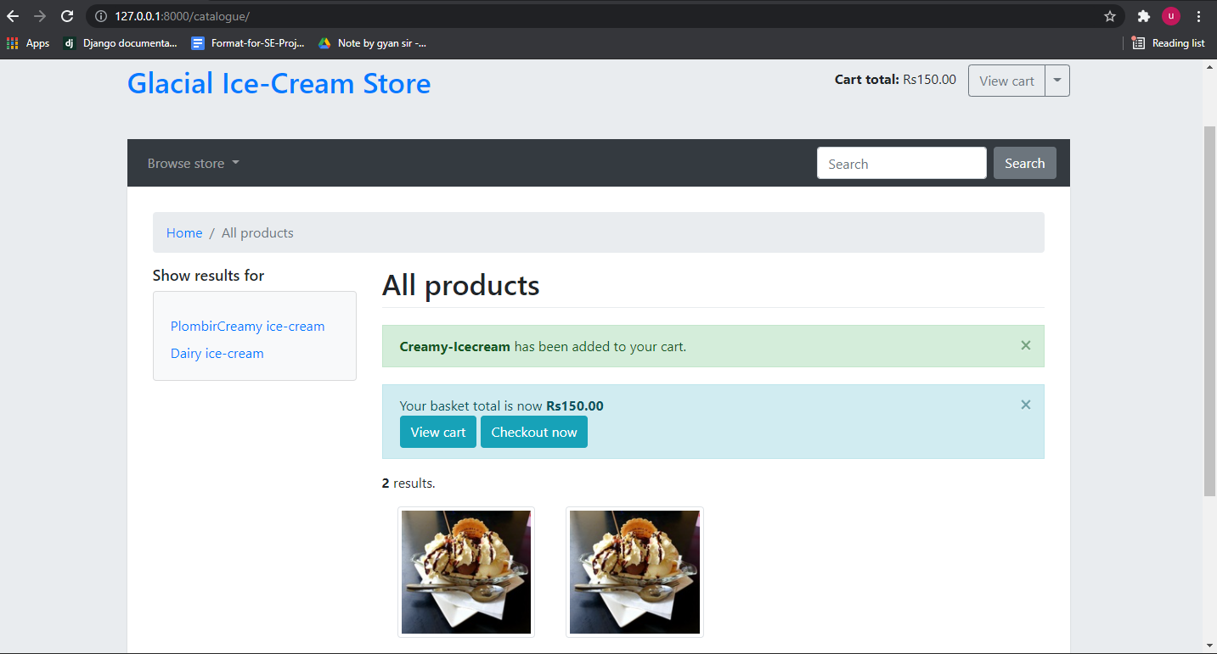

Figure 4.1.1

### Login/Register Page

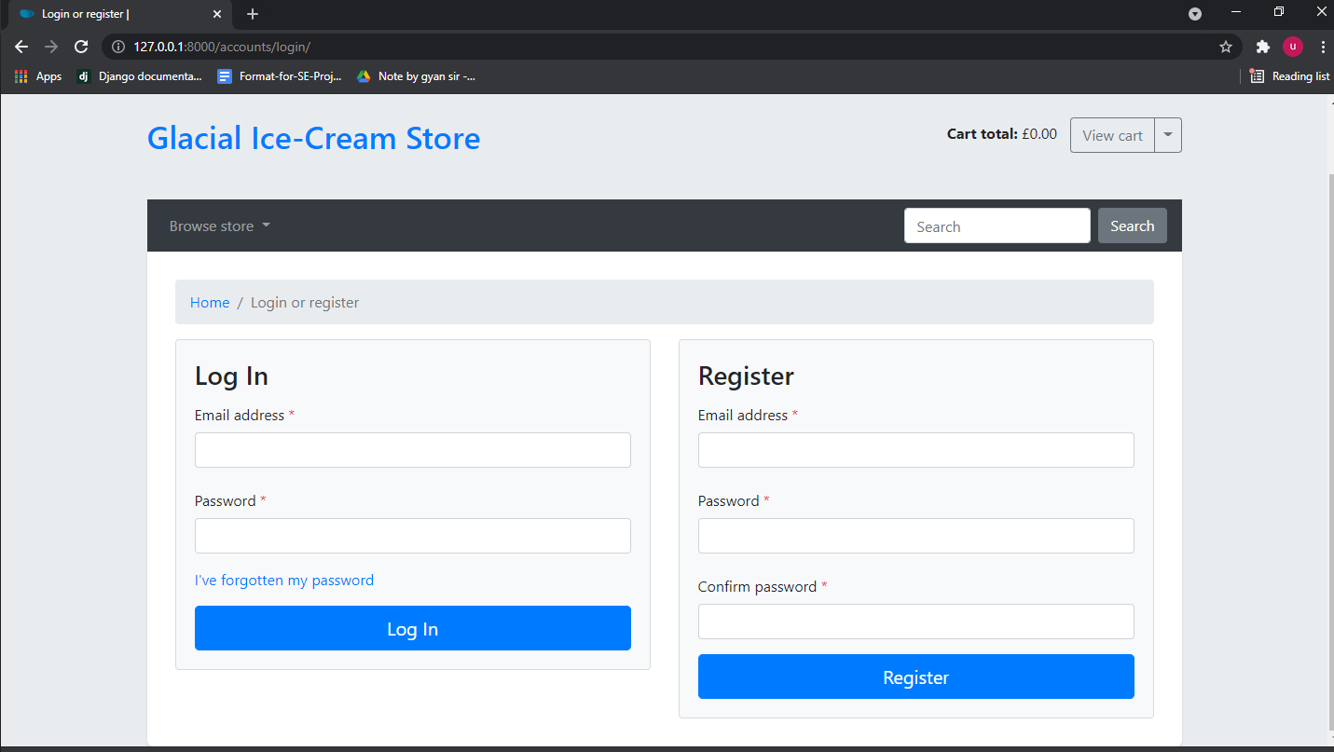

Figure 4.1.2

### Screenshot (45).pngDetail Page

Figure 4.1.3

### Cart Page

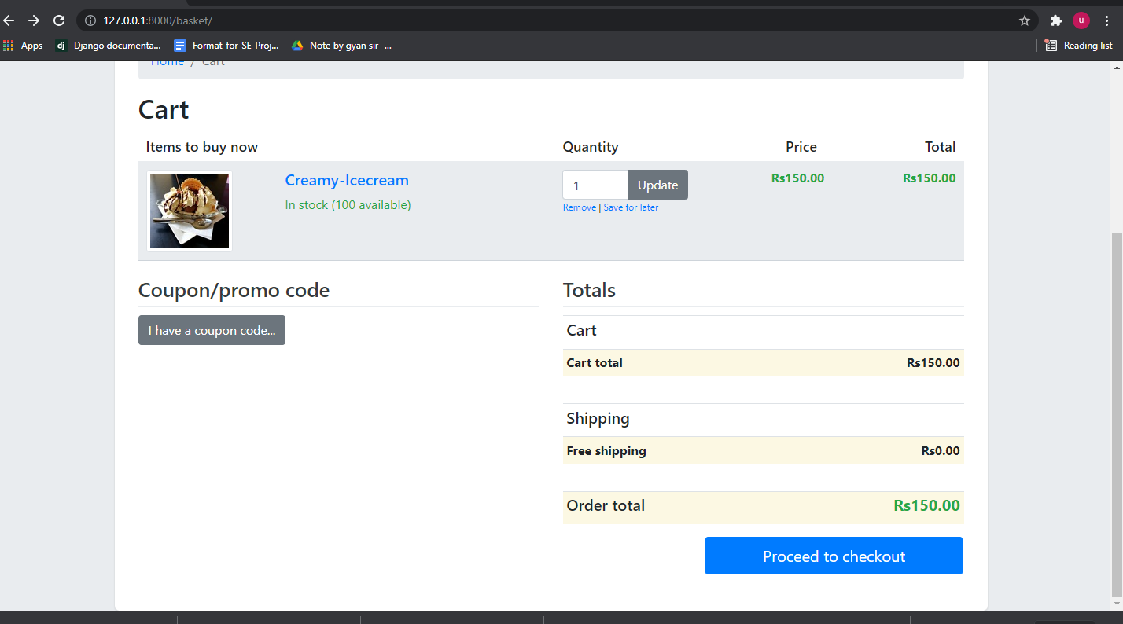

Figure 4.1.4

### Profile

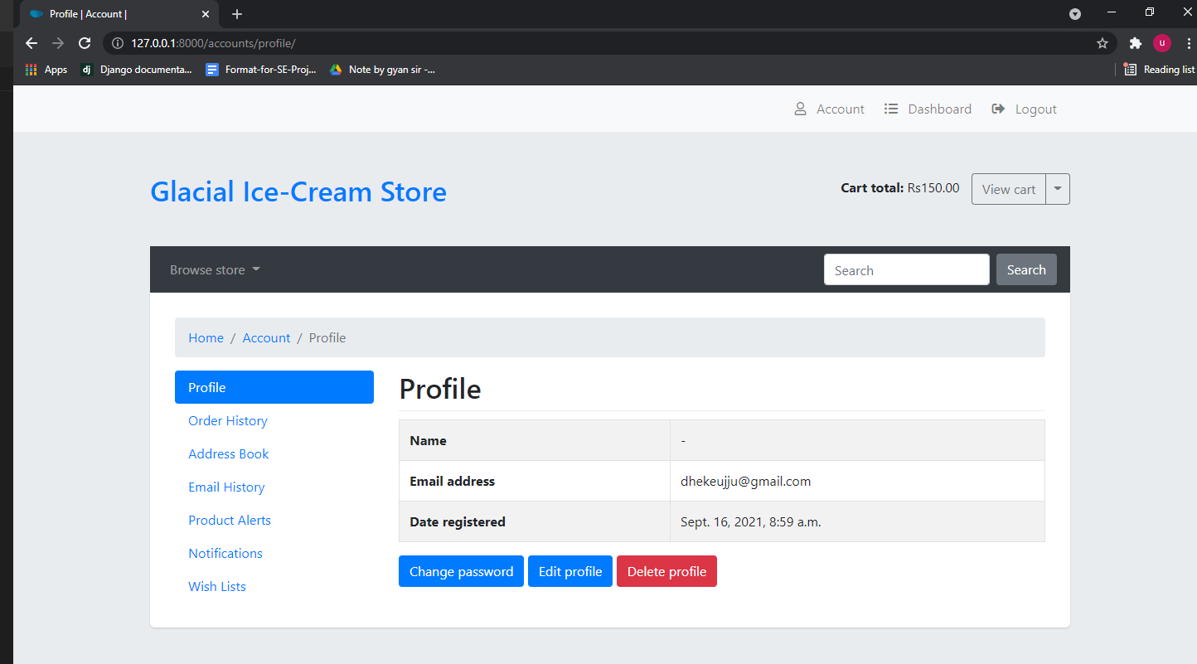

Figure 4.1.5

### 

### Dashboard

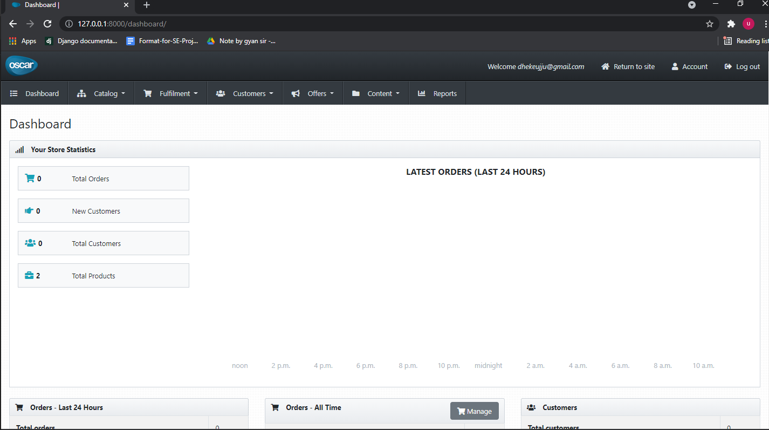

Figure 4.1.6

# Conclusion

The system developed provides a buying an Ice-cream products through the use of internet. It provides the facility of searching the product, adding the product to cart and buying the product. Online Transaction is supported in this website through which user can pay online or cash on delivery. It also provides facility for users to login into the system through which users can add the products to the cart and make the purchase. Admin can login and provides the dashboard from where admin can visualize all the information regarding total product sale, total number of products, total number of order, total number of order dispatched and many more. Admin can handle everything in the website through the use of admin panel.

**Biblography**

Oscar. (2021, May 2). Django Oscar Read Docs. <https://djangooscar.readthedocs.io/en/3.1/>

Lupton, P.W.; Stephan, H. (2010). [Six Days in Sicily](https://books.google.com/books?id=ShOHH0rXkggC&pg=PA106). Books on Demand. p. 106. [ISBN](https://en.wikipedia.org/wiki/ISBN_(identifier)) [978-3-8391-4844-0](https://en.wikipedia.org/wiki/Special:BookSources/978-3-8391-4844-0). Retrieved February 16,2015.

E-Commerce -Business Models. (2009, May 12). Tutorials Point. https://www.tutorialspoint.com/e_commerce/e_commerce_business_models.htm